University of Tromsø
Paper in Documentation Science Foundation Course
Autumn 2002
Notes
on
Notes
Candidate 28159
Tromsø, 29 August 2005

© Candidate 28159 2002

This document may freely be copied and distributed
for non-commercial purposes

Typeset with Garamond 11/15
Headings typeset with Arial in various sizes

Table of Contents

Preface iii
1 Introduction 1
1.1 Outlining the Issue 1
1.2 Limiting the Scope 1
1.3 A Model of Document Analysis 2
2 Analysis 3
2.1 The Function of Banknotes 3
2.2 The Early Major Design Elements 4
2.2.1 Text 4
2.2.2 Signatures 5
2.2.3 The Banknote Legal Document Complex 7
2.2.4 The Precursory Document Complex 8
2.3 Printing Technology and Design 10
2.4 The Use of Banknotes to Further Ideas of Nationalism 11
2.4.1 The Norwegian Coat of Arms 13
2.4.2 The Use of National Symbols before the Kroner Notes 13
2.4.3 The Use of National Symbols on the Kroner Issues 13
2.5 Denomination 17
2.6 The Competition with Other Forms of Money 18
2.6.1 Coinage 18
2.6.2 Documentary Payment Forms and Bank Accounts 19
2.6.3 Plastic Money 20
2.6.4 The Unofficial Economy 21
2.6.5 Overall Picture 21
3 Conclusion 23
Appendix A List of Note Issues 24
Appendix B Illustrations 25
References 29
List of Tables
Table 1 Text length of banknote issues 5
Table 2 Signatures on Norwegian banknotes. 6

List of Illustrations
Illustration 1 Norway S3: Jørgen thor Møhlen 25 rixdaler kroner 1695 25
Illustration 2 Denmark-Norway S15 Authorised notes 1 riksdaler, unissued remainders 25
Illustration 3 Denmark-Norway S32c Kurantbanken series II 1 Riksdaler kurant 26
Illustration 4 Norge 1115 100 kroner series I 1898 stamped and hole cancelled. 26
Illustration 5 Norway 1150-1157 London monetary reform issue, complete Specimen set (reverse). 27
Illustration 6 Norway 1150-1157 London monetary reform issue, complete Specimen set (adverse). 28

Preface
This paper contains a few illustrations, and without a clear view of the various notes issued by Denmark-Norway, later Norway, it could be difficult to follow all arguments.
As a basis for my work, I have used the major handbooks on Norwegian banknotes: Rønning (1980) for Denmark-Norway 1713–1813 and Skaare (1995) for Norway 1813–present. Interested readers will find the older material well illustrated there.
Norges Bank has recently (after I started writing the paper) published scans of all regular kroner issues at their web site, at the address: http://www.norges-bank.no/sedler_og_mynt/sedler.html. They have chosen to publish low quality scans. Higher resolution scans (but not complete) are to be found at this website, which also publishes some of the London issues and a few older issues: http://www.janeriks.no/Banknotes/index.htm.

I am grateful for this opportunity to follow up on a lifelong hobby of mine, banknotes; and I want to thank my teachers at the Department of Documentation Science. A special thanks to Per Bäckström, who has patiently tried to turn me in the right direction when I have been eagerly trying to go astray; and to Roswitha Skare who has tried to teach us the technicalities of writing a paper. The faults, errors and omissions in this paper are there despite their help.
I also want to thank Tim Jackson for his reading and commenting upon my English, his comments have been invaluable in preparing this paper. All remaining errors in choice of words, spelling, and grammar are entirely my own work.

Introduction

Outlining the Issue
In this paper I will try to show that the development of banknote design and the use of elements in the design can be seen as a result of a number of influences: the political and economic foundation of the note, technological developments, the need to make the notes secure and the possibilities for using the notes to advocate some cause.
The specific question under discussion could be phrased as: “How does the banknote document itself and its contemporary society?”
Paul D. van Wie (1999, v) states that
The act of creating coinage is manifestly political. It is also manifestly economic. And there are important, inescapable artistic and propagandistic overtones as well. For when a political entity creates coinage, it does not simply create blank disks. Coins generally carry a message: words and numerals, of course, but usually more than that. Political symbols, slogans, names, and language, all laden with ideology, bias, self-image, and national identity.
What holds for coinage does also hold for banknotes. They are not blanks, but filled with text, numerals and other symbols, laden with explicit or implicit meaning.

Limiting the Scope
The first Norwegian banknote issue was the third in Europe. The issue was the notes of Jørgen thor Møhlen in 1695. This means Danish-Norwegian banknotes gives us more than 300 years of banknote history and notes to analyse.
I have virtually no access to actual notes, especially older, but the notes of the national banks and their predecessors have all been described by Rønning (1980) and Skaare (1995). I have used these descriptions as a basis for my analysis.
When I refer to the notes themselves, either individual notes or groups of notes, I will not refer to any source other than identifying the note(s) or note issues. A list of note issues is given in Appendix A, where the relevant references to the catalogues are indicated.
As a collector of banknotes for 35 years, I have a lot of knowledge from reading about banknotes and from studying banknotes, either actual banknotes or pictures of them. A number of observations, generalizations and statements will draw upon this knowledge and will therefore not be attributed to any specific source.
I have chosen to limit my analysis to the visual parts of the note, i.e. elements easily visible to the user. Symbols intended to communicate something to the user will certainly be made easily visible. Other elements, e.g. those only visible under a magnifying glass, against good light or under ultra-violet light have been excluded from the discussion, as they primarily are intended to enhance the security of the issue, not to convey any message.
The analysis is largely limited to the issues of the national bank and its predecessors. Private banknotes are excluded, except for the Jørgen thor Møhlen notes, due to their being the first Danish-Norwegian issue. This delimitation of official notes is, I believe, in accordance with normal practice in Norwegian numismatics.

A Model of Document Analysis
Niels Windfeld Lund (1999) outlines a model of document analysis. As I understand him, he sees a document as a result of a documentation process. His model analyses document production and document reproduction.
In his analysis of document production, he sees the documentation processes from three different points of view: The technical/scientific, the social and the humanist perspectives; and he analyses five aspects: The producer, the field, the medium, the tradition and the document.
He also presents a model of document organisation and a model of document reproduction.
I will limit myself to analysing those elements of banknote production and reproduction that most affects banknote design, as this is my focal point in this paper.

Analysis

The Function of Banknotes
In Lund’s model (1999, 35) reproduction of a document includes how it is used. The function of banknotes, as a monetary instrument circulating in society, is thus a reproduction of banknotes. In his model of document reproduction, the user and the document takes the place of the producer and the field in his model of document production.
The idea or philosophy of money, however, belongs in the analysis of document production, as the existence of such an idea is a fundamental pre-requisite for any production of money, in any form.
Money in the form of coins has a history going back to the 7th century b.c. (Johansen 2001, 89). Coins, until recently, had value due to their content of precious metals, preferably gold or silver. Coins were produced by mints controlled by the government, who guaranteed their value in terms of metal content.
Historically, banknotes were not money but representations of money, in the sense that they would on demand be exchanged for money, i.e. coins, or that public offices would accept them on par with money for payments.
Paper money has no intrinsic value; the value has to be rooted in trust. Trust that the money I accept will be accepted as payment by others; and trust that the value will keep over time. If paper money does not achieve trust, it will be exchanged for coin as soon as possible or used for payment, while coins are hoarded. In both cases paper money will cease to function as money, it will loose value compared to coinage or will be redeemed for coin to such an extent that the issuer will be bankrupt.
In Denmark-Norway, the first note issues contained text that explicitly or implicitly (through references to Royal decrees) stated that they should be accepted as money. Later issues promised that the notes would on demand be exchanged for silver coin, after the creation of the Scandinavian coin union for gold coin (for exact wording of promises, see the actual text in Rønning 1980, Skaare 1995). In Denmark this practice ended in 1962, in Norway in 1945. After this, the notes have been fiduciary notes, i.e. their value rests upon trust in the issuing authority.
Money, as seen from a social point of view, has two primary functions that are of interest: As a medium of exchange and as a store of wealth. This makes it important that money a) actually can be exchanged for goods or services; and b) that the value of money is stable over time.
Economic theory tells us that the supply of money has to expand as the economy grows (see Glahe 1973, 122–173). This is very difficult to ensure, if the whole supply of money is based upon precious metals. The issuing of banknotes was therefore advocated as a means of ensuring an adequate supply of money and credit. Banknotes also had the advantages of being easier to transport, and wear and tear did not cause any actual loss of precious metals, as was the case with coins. Inadequate supplies of silver led Sweden to mint copper as giant coins (plåtmynt), weighing up to 19.710 kg (Tonkin 2002, 64) – a paper substitute was welcomed for purely practical purposes.
Coins in precious metals also have a strong tendency to be hoarded in times of unrest, causing problems for commerce and government.

The Early Major Design Elements
The early banknotes had major design elements that today are minor design elements. Below, I will try to describe their development and to explain why they were important design elements in earlier times.
One should bear in mind that the choice of design elements is the producers’ way of inducing the users to accept paper documents as money; contrary to the existing ideas of money meaning coined gold and silver, and contrary to the marked difference in intrinsic value between coins and paper.
Design, as it appears on the banknote, is a part of the technological perspective of the banknote production. The reasoning behind design, and the effects of design, belongs to both the social and humanist perspective of production and reproduction.

Text
All notes within the scope of this paper contain textual elements. The early notes are very like other official or legal documents of the 17th century, containing mainly text and signatures (see Illustration 1 and Illustration 2, p. 31 and Illustration 3, p. 32).
Table 1 clearly shows a trend, starting with long texts on the 17th and 18th century issues, getting shorter during the 19th century while post-war notes are virtually without text – the only texts relevant to the notes’ function being the name of the issuer and the denomination.
Modern notes are full of micro-text, as this is a security feature not meant to be read, but to be seen as lines or other parts of the design (i.e. seen without a magnifying glass), I have not included them in my concept of text in this discussion.
This development is explained below as a natural consequence of the banknote being a part of; and interacting with, two major document complexes: a legal document complex surrounding every banknote issue; and a complex of monetary documents existing at the time the banknote was first issued.
Table 1 Text length of banknote issues

Signatures
All regular Norwegian banknotes are signed by one or more persons representing the issuer or issuing authorities. This practise was both a security feature, ensuring that the notes were authentic; and a guarantee that the promises of the note be held by the issures.
Until 1901, all notes were signed by hand; from then on signatures have been printed on the notes. As a general rule, signatures, like (and together with) serial number and year, have been printed in black on the front of the note.
Table 2 Signatures on Norwegian banknotes” shows the development of banknote signatures. The thor Møhlen issue had three signatures on the note itself, and the same three on the counterfoil. According to the instructions regarding the signing of the notes, the person signing last should make a scroll on his signature so that it crossed over from the note to the counterfoil (Rønning 1980, 23).
Later issues had between one and six signatures, earlier notes tending to have more signatures than later ones, and high denomination notes having more than low denomination notes. It is easy to see that the number of notes made signing them hard work, and a number of persons had this as an occupation. High denomination notes, being relatively few, could have many signatures, while the much higher number of small denomination notes did not rate this costly treatment.
From series II (the first issue with printed signatures) to series III, including the small change notes and the London issues, notes had only one signature. This was generally the head cashier of Norges Bank, but the vice chairman of the board of Norges Bank signed the London issues.
From series IV on, the head cashier and the head of the central bank (chairman of the board of directors) have signed the notes together. This return to a larger number of signatures could be seen as a return to older practices, now without an extra cost.
In series VII, the signatures are placed on the back of the notes and they are printed as an integral part of the design, no longer in a separate printing like the year and serial number. This would indicate that signatures no longer have a real function, but are retained as a traditional part of the design only.

Table 2 Signatures on Norwegian banknotes.
Numbers indicate number of note issues.

The Banknote Legal Document Complex
One of the concepts of Lund’s model for analysing documents is the document complex (Lund 1999, 34). A document rarely stands on its own; it is usually one of a number of interconnected documents. One can often construct a number of such complexes for a given document, depending on what aspects of the document one wants to look at.
One such complex of documents that, in my opinion, is important for banknote design is the documents surrounding the banknote in its early days, making its function possible. It should be quite self-evident that giving out paper instead of coins in payment would be met with resistance, and that such an act would have to be preceded by legislation and information.
The foundation of the thor Møhlen issue lies in a royal decree of June 22nd 1695, in which the King authorises the use of certain notes in parts of Norway. The decree also (among other things) makes use of other types of notes illegal, and threatens penalties against those refusing to accept the notes as payment. On July 10th 1695, Rentekammeret issued detailed instruction regarding the design of the notes - how the signatures should be make, that one third be torn off as a counterfoil, the placing of the royal portrait, numbering, denominations etc. On August 10^{th,} information about the notes was sent to various government offices in the area the notes were intended for, together with an unnumbered note without denomination, in order that they inform the populace about the notes and how they were to be used. The project ended with a royal decree of August 21st 1696 about the recalling of the thor Møhlen issue.
These documents defined the thor Møhlen issue, with regards to how it should be used and how it should be designed. It also defined the design in that the whole text of the note is referring back to the first royal decree as an argument for the note’s existence and use.
The authorised notes 1713–1728 similarly refers to a complex of documents that the notes are a part of. A royal decree of April 8th 1713 authorises the issuing of notes, and contains detailed specifications about their design and use. It also specifies penalties for non-acceptance of such notes. A number of decrees were issued later, regarding design changes and withdrawal of certain notes, to be exchanged for new issues. A new decree about punishment for non-acceptance and regulation of other practises of June 27th 1714 makes it clear that acceptance was not universal. A placard issued by the chief of police in Copenhagen (in 5000 copies) points in the same direction.
This issue, as the thor Møhlen issue, has as its major design element a text, pointing at the royal decree authorising the use of the notes and defining their design, as shown in Illustration 1 p. 31.
Later issues refer to the bylaws of the issuing bank, or to the duty to redeem notes for silver or gold. While not explicit, as the documents referred to are rarely directly identified on the note, this is still references to other documents in the legal document complex surrounding and including the banknotes.
The change from daler to kroner is in itself an indirect reference to the Scandinavian currency union and to the law of currency of April 17th 1875 (Skaare 1995, 1:245) which introduced the new currency and authorised the issue of certain denominations in coins and banknotes.
Except for the gold redemption clause on series II notes, 20th century notes have been free from references to other documents in the legal document complex of the banknote. There is one notable exception to this. Until the recent issues, signatures on 20th century notes have been followed by the title of the signer. On the London issues, however, we find no title but the sentence ifølge særskilt fullmakt, “by special authority”.

The Precursory Document Complex
Another reason for the textual design of early banknotes is the fact that the idea of banknotes was not created in a vacuum, but as a development of an existing complex of monetary document types.
The thor Møhlen issue was, among other things, meant to replace the practice of issuing notes (IOUs, obligations) instead of paying out cash to workers at the copper mines of Røros (Rønning 1980, pp 22-23).
Among the forerunners of the notes of the Bank of England were the receipts given in exchange for deposits of cash, and promissory notes (Hewitt and Keyworth 1987, 9-10, 24-25).
The models for the first notes of the Stockholm Banco (kreditivsedlar) are a bit unclear, kopparsedlar being used as an argument but this is debatable (Platbārzdis 1960, 37-38; Lindgren 1968, 11). The later issues of transportsedlar have a likeness with cheques (Platbārzdis 1960, 78-79), and ran to 4 pages, as they – in principle – had to be endorsed every time they changed hands (op.cit., ill. 81a-d).
This adoption of traditions of predecessors made the early banknotes typical legal documents, incorporating text and signatures (and seals) as the major design elements. This is clearly shown in Illustration 1 p. 31 and Illustration 3 p. 32.
These traditions live on until today in Great Britain, where banknotes still “promise to pay”, and flourished until about 1836 in Sweden, when the last multi-page banknotes were issued (Lindgren 1968, ill. 61a-b).
Another predecessor of the banknotes is coinage. Banknotes were representations of coins, and it is not surprising that they also inherited some of the traditions of the coinage. Most early banknotes either had the royal monogram printed on them or embossed on them. The designs of the embossments, and their circular form, are strikingly similar to the design of contemporary coinage (for drawings of embossments, see Rønning 1980, 146–148). The printed monograms also bear close resemblance to monograms on coins. The thor Møhlen issue is a special case, with the royal portrait (again, similar to a coin) in a lacquer seal on the notes. This practice of coin-like embossments and royal monograms continued on Danish-Norwegian and Norwegian notes until – at least – the first notes of Norges Bank in 1817.
Around 1840 the banknotes seem to be an accepted fact of life in Norway, and the possibility of exchanging notes for silver – a long-standing, but un-kept promise – was instated 1842 (Skaare 1978, 57). At the same time, the combination of need to protect against forgery and development in engraving and printing technology made design that was more advanced both desirable and possible. From the two-coloured notes (i.e. notes printed in two colours, a coloured background print and a black vignette, from 1841) onwards we see a shift in design towards a new tradition, based in the needs and functions of the banknote itself – freed from the traditions of legal documents and coinage. Royal monograms have disappeared, so have embossments. The only break with this is the prominent part of the monogram of King Haakon 7th on the notes issued in London during the war (cf. Illustration 5 p. 33).
The representative function still made text, promising exchange for silver (later gold), necessary; but now – when the promise could be realized – it was downplayed. This promise of exchange, making banknotes representatives of “real” money, was retained long past its reality. It disappeared from Norwegian banknotes with series III in 1945, but the duty to exchange notes for gold had been suspended 1914–1928 and from 1931 onwards (Skaare 1978, 61). The near absence of text in modern Norwegian notes reflect their status as fiduciary money, i.e. money which value is rooted in trust only.
The disappearance of text, monograms and embossments made space for other design elements. As this development of banknote design made its start in the 1840’s, this coincided with the advent of nationalism as a strong movement in Norwegian mental life. This, as we shall see in part 2.4 “The Use of Banknotes to Further Ideas of Nationalism” (p. 14), made a deep impression on Norwegian banknote design.

Printing Technology and Design
In theory, a banknote does not need more than a statement of denomination and, possibly, the name of the issuer, to function as money. Such a design would, however, be very easy to forge.
Forged notes have two effects that one would want to protect against. The producer of genuine notes would have to redeem more note than was issued; and the trust in the genuine notes would disappear if forged notes circulated in some quantity.
The history of banknote design can be seen as a continuing process or battle between actors in a banknote technology complex: The legitimate banknote producers, i.e. national banks or banknote printing companies on the one side, and criminals on the other side. This complex can also be seen as a document complex in which banknotes are a part, as I understand Lund (1999).
The security elements in banknote design are chosen so that the note contains a complex of techniques needing specialised competence and machinery to produce genuine notes, while the costs of producing notes still have to be kept under control. Another important security element is quality control, to ensure that all genuine notes have identical look and feel. If one lets low quality notes out, it will make it easier to circulate counterfeit notes.
The security features of early notes were few. They were printed like books, set with loose types. Embossings (i.e. raised symbols made by pressing a stamp against the paper) that easily became smudged and incomprehensible when notes circulated, was one security feature. That the paper was watermarked was probably the best security element. A weakness in early notes were that denominations were hand-written, not printed. This made alterations possible. Rønning (1980, 55) shows how this influenced the first notes of Kurantbanken. Almost 10,000 daler more was redeemed than had been issued, most of this because denominations had been altered. Only of the smallest denominations did one redeem forged notes.
Vignettes were introduced to make forgeries more difficult. One also printed penalty clauses on the notes, stating that forging them would be punishable by death and that reporting forgers to the government would lead to monetary reward. This still did not deter everyone from forging money. Strangely, this inefficiency in preventing forgeries has not made such warnings disappear. There are numerous modern banknotes from other countries where such warnings as “La loi punit le contrefacteur” have their place even today. The copyright symbol on the notes of series VII may be seen as a modern version of this sign of legal protection.
As printing techniques then meant that new printing plates had to be made constantly due to wear, one had to keep the design simple enough that one could make new plates that were identical to the old ones.
In the early 19th century a number of techniques were invented, that would transform the design of banknotes. One was to engrave in soft steel, which then would be hardened. This made longer print runs possible before engravings had to be worked over or replaced be new. One also developed the technique of transferring gravures from hardened steel to soft steel that then was hardened again, so that one could make a number of identical printing plates, ensuring uniformity and quality of printed notes. Another invention was a lathe that could make and engrave complicated geometrical patterns called guilloches, patterns that it was impossible to make or engrave by hand.
Freed from the constraints of the older techniques, banknotes now could be filled with colours, ornaments and pictures, making them pleasing to the eye. This attractiveness must, however, be seen as a result of artistic solutions to the problem of preventing forgery, not as the primary goal to be attained.
While forgeries had been a major problem with early issues, the new techniques made counterfeiting a major venture where a number of competent tradesmen had to be involved, and demanding a large initial investment.
As new advances in printing technology made new security features available or made forgeries of circulating notes easier, the issuing banks issued new series of notes. When photographic reproduction became a possibility, notes were filled with elements like micro lettering, making correct reproduction impossible. Today’s colour photocopiers has necessitated the use of intaglio prints that shows special symbols when viewed at an angle, metallic holographic elements that cannot be photocopied, lettering on metallic threads in the paper where the text only can show up under strong backlight and so on. There are also elements that are only visible under special light. The watermark is a technique that has survived from the first days of the banknote. On a modern banknote, everything is filled with print except – possibly – the area where you find the watermark.
Most modern notes are the result of three different printing principles: The background is often printed in offset; major pictorial ornaments are printed in intaglio printing while serial numbers, years and signatures are printed in letterpress printing. The high cost of engraving for intaglio printing makes it too costly for printing the whole note. Engraving, which was a common technique for illustrations, has almost disappeared from other kinds of documents than paper money, stamps and other documents where security demands such techniques.

The Use of Banknotes to Further Ideas of Nationalism
When text gave way to other design elements, these elements had other functions than merely furthering the function of the note, or being neutral decorations. Semiotics tells us that there is no such thing as a neutral design element.
Semiotics is the science of signs (Fiske1990, 39-60). There are a number of models of the sign, among them the models of Peirce and of Saussure. What they have in common, is that they see the sign as interplay between a physical object and a mental image or idea. The physical sign derives its meaning from the mental sign it evokes in the reader of the sign.
Fiske (1990, 85-92) describes Roland Barthes theory of the two orders of signification. The first order is the denotation of the sign, i.e. the everyday, common sense or lexical meaning of the sign. The second order of signification is described as three ways the sign can work. These are connotation, myth and symbol. Connotation is the interaction between the sign and the emotions, values or ideas of the reader, when the reader of the sign becomes just as important in defining the meaning of the sign as the sign itself. Myth is an interrelated set of ideas or concepts surrounding some aspect of life or society. A symbol is an object that through convention has become a sign of something else. All these aspects of signs are important in seeing how banknotes in varying degree are expounding nationalism or other ideas.
These ideas also imply that there may be a difference between the conscious intention of the active user, or maker, of a sign, and what implications we, as readers of the sign, can draw from it. In the following, I will describe how I decode the use of signs on banknotes; this does not necessarily imply intention on the part of the note designers.
Benedict Anderson shows how nations are constructed as imagined communities. According to Anderson (1991, 170-185), maps and museums are important factors in this construction. Maps show how the nation is physically delimited and, when e.g. hung in classrooms, give the pupils a mental picture of their nation. Likewise, museums show what historical facts and stories are important in defining the nation. Anderson is writing about emerging nations in what today is termed the Third World; nations that had been constructed by colonial powers by drawing lines on a map, regardless of linguistic, economic, religious or ethnical boundaries or connections. Norway as a geographical term and as a defined political and national entity goes back to the early Middle Ages, and is not an artificial construct like many of the nations Anderson (1991) writes about. Still, Norway has been subservient to Denmark, later Sweden, for centuries, and has only relatively recently become an independent nation. The constitution of 1814 made an impact on the status and political autonomy of Norway; this has been a major influence on the design of Norwegian banknotes in the 19th and 20th century.
Maps, as Anderson sees them (ibid., 170-178), are used to make the geographical definition of the nation stand out from the rest of the surrounding world, and to define what geographical entities constitutes the nation; thereby imposing a mental map of the nation on the spectator. In museums one collects and displays artefacts, thereby constructing myths, that defines the nation in terms of its history. I will regard banknotes as a kind of travelling maps or museums, circulating in the populace and exposing them to the same symbols and myths as maps and museums do. Banknotes do tell a story, and in the case of Norway, much of the story is about a nation struggling to define itself in terms of its history.
Another point about banknotes is that they – at least until modern times – were inherently national. While coins could circulate well outside the area reigned over by the monarch issuing them as long as their metal content was as promised, banknotes were backed by legislation and trust and could not function outside their defined area. Not until coins lost their intrinsic value, and banknotes could be exported, did banknotes become an international commodity. The higher denomination banknotes of Norway (500 and 1000 kroner notes) could not be legally exported until 1982 (e-mail from Bank of Norway, 12.11.02).

The Norwegian Coat of Arms
The Norwegian coat of arm, a lion standing hold an axe, is an old symbol for Norway, and was first used on coins about 1285 AD (Skaare 1995, 1:78). It was also used on coins during the Danish rule, but was not used on banknotes of the same era.

The Use of National Symbols before the Kroner Notes
On the notes from the era of Danish rule, we generally find a royal portrait or monogram in an embossed stamp or printed on the note. In the days of absolute monarchs, the state was the area ruled over by the monarch, so using personal symbols of the monarch would be natural.
With the first notes of Norges Bank came the use of the Norwegian coat of arms, symbolising the nation of Norway. This can both be seen as a new tradition, marking the near-independent status of Norway, and as a natural consequence of the fact that the king was not any longer an absolute monarch.
Later issues also incorporate symbols of major industries or trades in Norway; this exhibition of national characteristics conveys a myth (in Barthes’ sense) about Norway and defines Norway in terms of its modern economic life.

The Use of National Symbols on the Kroner Issues

Series I
The first series may seem quite self-contradictory in its use of symbols. A major element is a portrait of the king, Oscar II, in a Swedish admiral’s uniform (see Illustration 4, p. 32). This is a break with the tradition of having no royal symbols on the banknotes of Norges Bank. There is no record (Stixrud 1995, 1:39-40) of why this portrait was chosen for the notes. He is, however, not portrayed as a monarch, he wears no crown and no title is given, in contrast with contemporary coinage where his status as king is clearly communicated. And it must be argued that however much he was king of Sweden, he was also king of Norway.
Another main symbol on the notes is the Norwegian coat of arms, a clear indication of Norway as a semi-independent nation. Yet another set of symbols are the coats of arms of the six bishoprics. Through them, the note displays how Norway is made up of parts. It should be noted that these symbols e.g. does not advocate historical claims like claims to the Norwegian dependencies lost in 1814. To the modern mind, this might seem quite natural, but both coats of arms and mottos have historically been used to proclaim dynastic or territorial interests beyond contemporary reality. E.g., the title “de goters och venders” [King of Goths and Wends], proclaiming sovereignty over possessions in Germany, was a part of the title of Swedish kings until 1872, long after the territories in question had been lost. One should bear in mind that the territorial claims of Norway in Greenland was not forgotten at the time, Norway occupied parts of Greenland in the 1930’s and used the historical connection as an argument in the Haag international court.

Series II
The second series, on the other hand, points in a nationalist direction only. It was first issued in a period of rising opposition to Swedish rule, and after an era where national romanticism had had its heydays. The ornamentation of the notes is clearly marked by references to ornamentation and symbols from Norway’s Middle Ages. The one person portrayed on all notes has clear connections to the Norwegian striving for independence in 1814, while the naval hero depicted on three of the notes was a person mythologized and romanticised for his derring-do, fighting against the Swedes. Admittedly, he was serving in the Danish navy, but he was clearly seen as an example of Norwegian courage and seamanship.
The larger denominations (from 50 kroner and up) of this issue have historical buildings on the back, together with the Norwegian coat of arms surrounded by the arms of the bishoprics. Three of the four buildings are major buildings from the era of Norwegian independence before Danish rule. Two are castles – one of them built to defend Norway against the Swedes – and the third is a cathedral devoted to the patron saint of Norway, worshipped throughout Scandinavia. The fourth building is the mansion at Eidsvold, where the constitution was worked out in 1814. Seen together, the notes show us a country looking back to its days of glory to define its history, showing defiance to its dominating neighbour and union partner. In their bringing together of defining symbols and conveying the myth of Norway, they closely resemble the museums described by Anderson (1991, 178-185).

The London Issues
The London issues, with their use of the king’s monogram as a major design element in addition to the Norwegian coat of arms, does also break the tradition of not using the king’s person or signs of the king on the banknotes of Norges Bank. During the war, the king became a very important symbol for the Norwegians, and he was seen as an important unifying element at a time when party politics had been discredited. His monogram was a well-known symbol, and had been used on coins for decades. In preparing for a situation that could be chaotic, it was natural one should exploit the king’s standing for an issue of banknotes. It is also telling that in doing so, one defines Norway as a nation loyal to its king – thereby excluding collaborators and, possibly, communists who by definition should be anti-monarchists.

Series III
Perhaps the most striking feature of the notes of series III, if one excludes their almost majestic austerity and lack of artistic design, is that they actually were chosen for the monetary reform in competition with the colourful London issue (see Illustration 5, p. 33 and Illustration 6, p. 34). The only nationalistic symbol on these notes is the Norwegian coat of arms.
The choosing of this issue, instead of the London issue, may be telling a tale of political considerations. One thing is the royal monogram on the London issues, possibly excluding the communists. The communists had become a large political force in Norway and had done great services in the underground movement, and one should also remember that the Red Army recently had liberated parts of Northern Norway, at the cost of many Soviet lives. Choosing the locally designed and produced issue also paid homage to those who risked their lives to design and produce them, and hence, in an indirect way, to all those who had been part of the underground resistance.
The design of these notes also documents their pre-history. They had to be designed and produced in secrecy, so that neither the Germans nor the populace got wind of what Norges Bank had planned. If the Germans discovered what was happening, an ill fate awaited those responsible. And if the populace found out of the plans, the whole work would be in vain. Therefore, the notes had to be made with what little expertise and other resources were available in Norges Bank, involving as few persons as possible and without access to outside resources that normally would have participated in both design and engraving.

Series IV
The history of the notes of series IV is long, starting in 1922 (Stixrud 1995, 1:68) and ending with last notes being issued in 1976 and finally being demonetised and made valueless in 1999. The history of the design of this issue is told and well illustrated in Stixrud (1995, 1:68-126; 2: ills. 50-71).
Nationalism is still a major part of the design, no more directed against a common enemy but more trying to instil a sense of community and common values, telling a myth of a united people striving together to build the nation. The adverse (portrait side) shows famous Norwegians (i.e. famous in Norway, internationally neither Michelsen nor Wergeland would be household names). Many of them were also important in defining Norway or the Norwegian, both to Norwegians and to foreigners. The reverse shows scenes from Norwegian daily life, with each note representing a trade or industry: fisheries, trade and shipping, farming, forestry, mining and industry, and finally arts or intellectual work. In this way, the notes make a mental picture of Norway and its daily life, with people struggling together to make a living and to make a community. Monuments and castles are markedly absent, Norway is no more exhibiting a glorious but distant history; today’s exhibition is looking forward, at a united country building the future. An idyllic picture, but one that is congruent with the post-war political and social climate of co-operation and inclusion.

Series V and VI
In series V, the nationalism is more downplayed than in earlier issues. While series II and IV had a discernible nationalistic programme, the programme of series V seems more to be an exhibition of this and that that could represent Norway, a kind of tourist brochure telling of famous Norwegians and nice things to see while in Norway. We have the same persons as in series IV, less Michelsen, but the reverses are a series of pictures without any internal connection: fisheries and shipping on the 10 kroner note, Borgund stave church on the 50 kroner note, the Constitutional assembly at Eidsvold on the 100 kroner note, the University of Oslo on the 500 kroner note and a coastal scene with a lighthouse on the 1000 kroner note.
In series VI, all persons have been changed. Save for Grieg on the 500 kroner note, we find persons that were only vaguely known to most Norwegians. The reverses all shows works of artisans. While the Norwegian coat of arms is prominently displayed on the notes of series V, it has disappeared in series VI.
Increasingly, the notes seem to have lost their function of furthering nationalism and building a nation. The community building function of creating and displaying a common knowledge of Norway’s culture is retained, however.

Series VII
Series VII continues the traditions of series V and VI, in that nationalism as such is no longer a theme, but the display and communicating of Norwegian culture is continuing.
A new feature in this series is that the whole note is centred on the person depicted, in that all design elements are connected to this person. Interesting, too, is the fact that for the first time a majority of persons depicted may be equally, if not more, well-known internationally than in Norway.

The Euro
While Norway is not yet a member of the European Union, the idea of using the Euro as currency in Norway has been advocated. There is also a possibility that Norway some day will convert to Euro as a possible future member of the EU.
While Norway’s banknotes have been nationalistic in their design, the design of the Euro was intentionally a-nationalistic. No country should find their symbols on the notes; France should not have a denomination greater or smaller than Germany. Their design is dominated by architecture on the adverse and bridges on the reverse. No actual building or bridge is featured; this is “generic” illustrations without any national overtone. A map of Europe, which – in contrast to the coins – also includes nations that are not members, the flag of the Union and the stars used in the flags are the only symbols showing the origins of the notes.
As “circulating museums”, (cf. the first part of 2.4) these banknotes must constitute problems. How can they instil a sense of common history and experience in the users, when the notes shows nothing that can be identified and thereby evoke feelings? The maps can possibly help make a mental map of the union, but as such, it is incorrect in that it also shows non-members. The a-nationalistic design of course overcomes dangers that would be inherent in choosing identifiable objects or persons to exhibit, but this also curbs the notes in their nation-building capacities.

Denomination
The denominations have varied considerably through the ages. As various issues have been denominated in different currencies – all named daler, but with differing actual values in silver coin – I will not compare the denominations of the different issues.
Until about 1750, denominations generally were handwritten in the text of the note, and numerals were not used until about 1750. From then on, the denomination was printed in text and numerals. This has implications regarding the users of banknotes. In a country where most of the population were analphabets, textual documents could only function well in the classes who could read and write, i.e. the middle and upper classes. The choice of denominations also indicates that these classes were the intended users. Later developments, necessitating increasingly lower denominations, also brought forth numerical indications of denomination, making it easier for analphabets to use banknotes.
Denominations varied with the state of the government finances. In hard times, banknotes were issued for small amounts, in better times only notes denominated with a value of at least 1 daler were issued.
The kroner notes were first issued as 5, 10, 50, 100, 500 and 1000 kroner notes. This series of denominations has been surprisingly stable; the 5 and 10 kroner notes were abolished in 1963 and 1984 respectively, while the 200 kroner note was introduced in 1994.
This stability is not matched by a corresponding stability in the value of the kroner. The purchasing power has dwindled to a mere 2 per cent of the original value since the kroner were introduced in 1875. This means that the 5 kroner note had a purchasing power of about 250 kroner today. At the same time, the real value of wages, or the purchasing power of labour, has increased strongly. 5 kroner represented two and a half day’s labour for a skilled labourer of 1875 (Statistics Norway. n.d.). The 1000 kroner note represented a purchasing power of 50 000 kroner today, and was equal to about two years’ pay in 1875.
The mismatch between the development of the denominations of notes and the purchasing power of the kroner will be further discussed in the following.

The Competition with Other Forms of Money
There are numerous types of money, banknotes are just one of them, and a type we know well from our own experience. In reality there are, and have been, a number of document complexes competing for the role of money in society.

Coinage
At the start of the era of banknotes, gold and silver (and to some extent copper) minted as standard coins with a denomination close to their intrinsic worth, were the only universally accepted money in Denmark-Norway.
As discussed in part 2.1 “The Function of Banknotes” this kind of money had some weaknesses that banknotes could overcome. However, banknotes were obviously seen as a poor substitute for real money by the populace. The number of royal decrees threatening punishment for non-acceptance and otherwise enforcing the use of banknotes shows this.
Gresham’s law (cited in Scott 1930, 26) says that poor money will drive good money out of circulation. This means – in our context – that given the choice between paying out gold or silver coin on the one hand, and banknotes on the other hand, you will always give away the banknotes (as long as you perceive them to be inferior in value) and keep the coins. The effect of introducing banknotes will be that coins disappear from circulation – not because banknotes are seen as better, but because they are deemed inferior.
Banknotes were normally issued as notes that could be exchanged for gold or silver coin on demand. Normally, legislation would put limits on the total outstanding issue, either as an absolute sum or as a sum or factor over the issuing bank’s actual holding of gold or silver.
If too many banknotes were issued, holders would come to the bank and demand coins in return. If enough did this, the bank could not meet its obligations and redemption would have to be suspended – reducing the credibility of the bank and its issues even further. The issuers thus had ample reason to strive for parity between their notes and coinage.
While these mechanisms holding the note issues within limits obviously had their function protecting the economy against strong inflation, they also had their drawbacks. This was fully demonstrated in Norway during the 1920’s and 1930’s, when Norges Bank followed a monetary policy aiming at restoring redemption of notes for gold at the rate stipulated in 1875. This policy led to deflation and an economic crisis, which took years to overcome. Norwegian notes have been irredeemable, fiduciary notes since 1931 (despite their own wording until 1945) and this has been efficient. In reality, the competition between gold and silver coins on the one hand, and banknotes on the other hand, was over when Norway stopped minting silver circulation coins in 1920. For all practical purposes, coins without actual intrinsic value cannot compete with banknotes – at least not for payment of larger sums.

Documentary Payment Forms and Bank Accounts
As shown in 2.2.4 “The Precursory Document Complex”, banknotes had other documents as predecessors. These documents – drafts, bills of exchange, obligations, cheques etc. – lived on, parallel to banknotes. They had proved useful in effecting transactions between merchants, and have lived on until this day. They were, though, not general instruments of payment, so they could only partially compete with banknotes.
With the advent of a well-functioning banking system, some of these instruments – like the cheque – gained strength. New monetary instruments, directly competing with banknotes and coinage, also saw the light of day. The most important such instrument was the bank (or savings) account.
Hoarding money, be it coin or banknotes, had been the only way of storing monetary wealth. In a society where there were few institutions of credit, you had to save money to invest in e.g. a farm, a house or a fishing boat. Hiding away cash was one of the important ways of saving. (A more productive way was to buy a part of a farm.) When the first savings banks were started, one of the reasons was to give savers a safe place to put their money, safe from fire and theft – and even accruing interest. Gradually, such accounts came to take a major place as a store of wealth, in direct competition with coins and banknotes.
A further development came with the increasingly more effective services of account-to-account transfers. This made it possible to settle debts over long distances and without actually involving cash. Folio accounts increasingly took over many monetary functions.
With the introduction of electronic data processing for keeping accounts in the Norwegian banking system, one had the resources to process a large amount of cheques. In the 1960’ and 1970’s the old practice of paying out salaries in cash gave way to transfers from the bank accounts of employers to the checking accounts of employees, and checks became the preferred method of payment for medium sized and large amounts.

Plastic Money
A development of bank accounts are “plastic money” or “electronic money”, money substitutes (competitors) based on a bank account (or a similar device).
“Plastic money” got its name from the plastic cards associated with them. These stem both from the credit cards that were invented in the US in the 1950’s, and from the check guarantee card used by Norwegian banks to facilitate use of checks in the 1960’s and 1970’s. These cards were developed into cards that could be used to get cash from an ATM (Automated Teller Machine or Cash Dispenser), later to pay at an EFTPOS terminal in a shop.
These instruments were developed to take the place of checks, that had proven very costly, and to minimize the need for cash handling in shops and banks. The effect is that with a small card you can have full control of you bank account, without ever visiting your bank and with the use of very small amounts of cash.
“Electronic money” are solutions that makes it possible for you to effect payments and other transactions electronically, e.g. through your bank’s internet banking solution.
For the banks, the point is that as long as they can make you keep your money in your account, it can be lent to others. At the same time, they want to avoid the costly and risky handling of cash amounts, and they transfer the manual work with money transfer from themselves to their customers.
Cash, both as coins and as banknotes, have been relegated to a secondary place in a modern society’s payment and wealth storing systems.

The Unofficial Economy
While the amount of actual cash in circulation has had a slow decline over the last 10 years, measured as a percentage of GDP or household income, the last two years has seen a decline in the actual amount circulating. It is still an astonishing 40 billion kroner or about 8000 kroner per capita (Norges Bank 2002, 33-34). Most of us will reflect that this amount is very much larger than we usually have lying around.
Anyone with a practical banking experience will know that a number of people, especially elderly, have deep-rooted suspicions against banks and will prefer to hoard their wealth in the form of cash. This often comes to light when they are robbed, or when unsuspecting heirs come across large amounts when tidying up – or upholstering old furniture, redecorating rooms or otherwise.
Another class of customer are those who fear taxes more than death, preferring to keep cash in bank vaults instead of in interest bearing accounts.
The major explanation of the large amounts of cash in circulation is probably crime. Not the petty wealth tax avoidance described over, but large-scale tax avoidance and smuggling and distribution of heavily taxed or illegal substances – alcohol, drugs, and narcotics (Norges Bank 2002, 33).
In order to make the transport and hiding of large sums impracticable, Norges Bank does not want to make notes of larger denominations than 1000 kroner. As shown in 2.5 “Denomination” the decline in value of the kroner since 1875 would have made making larger notes reasonable, but the growth of other means of payment for legitimate trade makes banknotes a means of payment for minor sums outside the black-market economy. Other countries have abolished their larger denominations, e.g. Sweden the 10,000 kroner note, USA the notes of 10,000, 5,000, 1,000 and 500 dollars, UK notes over 50 pounds etc. It is also a point that the fight against white-washing makes it a goal to make most transactions traceable, which they will be when handled as account-to-account transfers or by other electronic means of payment. In this respect, banknotes have become impractical documents for the authorities.

Overall Picture
Banknotes won the competition against coinage to become a preferred means of payment during the first half of the 20th century. In the same period, banknotes have been fighting a losing battle against other forms of money for storing wealth.
Developments in banking, made possible by extended use of information technology, has over the last few decades brought forth new forms of money, leaving little room for banknotes in the legitimate economy.
The fight against the black-market economy has also curbed what would have been a natural development of the banknote institution.

Conclusion
Tradition is one of the aspects in Lund’s model for document production (1999, 30). But can we talk of a tradition of banknote design? The techniques used for production have changed over years, the role of banknotes and their function has changed, and so has their appearance. The monetary ideas behind banknotes have also changed.
I believe it is wrong to demand total stability from a tradition. Yes, banknote design has changed markedly in the 300 years they have been with us, but so has their times. The hallmark of a tradition must be that things change in response to changed circumstances, in order to preserve the functioning of the central theme of the tradition – in this case the banknotes. Traditions that are not adaptive will cease to exist. So far, banknotes have shown a remarkable degree of adaptation to changed circumstances.
I will conclude that there is a tradition of banknote design, and that this tradition has changed as external influences have made it necessary. Major external influences have been introductory problems with acceptance, inflationary practices, forgery, printing technology, ideological changes, economical changes, the unofficial economy and changes in the concept of money.
Given the development of banknotes as presented in this paper, one could pose the question: “Is there a future for banknotes?”
Banknotes have gone from representatives of real money to everyday and trivial instruments of payment. Their design has become increasingly complex in order for them to be trusted. They have met serious competition from other monetary instruments. Technological change, not in the design and production of banknotes but in the making of other kinds of money, e.g. electronic money, will be the major obstacle for banknotes. Norway probably will develop technologies that will make banknotes superfluous for most of today’s users. Tourists, who will have difficulties in integrating themselves with an electronic monetary infrastructure, will probably be the last legitimate users of banknotes. The unofficial economy will still need cash; this is one of the major reasons for abolishing banknotes. Given the historical development shown in the preceding, one could prognosticate that Norway should abolish banknotes sometime between 2010 and 2020.
Money will then be electronic and traceable, and will be transported or controlled by plastic cards like those we know today. They are designed as billboards, marketing national and international private financial institutions. They, like the Euro, will lose the function of “travelling museum” and will not create communities like those that today’s banknotes do. This will be a loss in our everyday life.
Appendix A List of Note Issues
Issue | First year | Last year | Range of denominations | Note | Catalogue
thor Møhlen | 1695 | 1696 | 10-100 riksdaler kroner | Private issue with royal backing | S1-S5
Authorised notes 1713-1728 | 1713 | 1718 | 1-3 mark, 1-100 riksdaler |  | S7-S22
Kurantbanken Series I | 1737 | 1748 | 10-100 riksdaler kurant |  | S23-S28
Kurantbanken Series II | 1748 | 1793 | 1-100 riksdaler kurant |  | S29-S33
Kurantbanken Series III | 1785 | 1813 | 1-100 riksdaler kurant |  | S34-S38
Small change notes 1809-1814 | 1809 | 1814 | 8-24 skilling kurant |  | S39-S41
Speciebanken | 1791 | 1810 | 4-80 riksdaler species |  | S42-S46
Treasury notes | 1808 | 1811 | 2-20 riksdaler kurant |  | S47-S48
Rigsbanken | 1813 | 1820 | 1-500 riksbankdaler | Last issues in Norway 1814 | 1064-1068
Government commission | 1807 | 1807 | 12 skilling, 1-100 riksdaler kurant |  | 1069-1073
Riksbanken Norwegian branch | 1813 | 1814 | 1-100 riksbankdaler |  | 1074-1077
Governor's notes | 1814 | 1814 | 1-50 riksbankdaler navneverdi |  | 1078-1082
Interim national bank | 1814 | 1814 | 3-16 riksbankskilling, 1/2 riksbankdaler |  | 1083-1087
Bank of Norway one colour 1817-1840 | 1817 | 1847 | 24 skilling, 1/2 speciedaler, 1-100 speciedaler |  | 1088-1098
Bank of Norway two colours 1841-1865 | 1841 | 1866 | 1-100 speciedaler |  | 1099-1106
Bank of Norway multicoloured 1866-1876 | 1866 | 1877 | 1-100 speciedaler |  | 1107-1112
Bankof Norway series I | 1877 | 1899 | 5-1000 kroner |  | 1113-1118
Bankof Norway series II | 1901 | 1945 | 5-1000 kroner |  | 1119-1124
Small change notes WWI | 1917 | 1925 | 1-2 kroner |  | 1146-1147
Small change notes WWII | 1940 | 1950 | 1-2 kroner |  | 1148-1149
London reform notes | 1942 | 1942 | 1-1000 kroner | Printed in exile in preparation for a monetary reform after the war, not used. | 1150-1157
London liberation | 1944 | 1944 | 5-100 kroner | Printed in exile for use under an occupation of Norway, used to some extent during the first weeks of liberation. | 1158-1161
Bankof Norway series III | 1945 | 1954 | 5-1000 kroner | Printed in secrecy during the war in preparation for a monetary reform, used for this purpose. | 1125-1129
Bankof Norway series IV | 1948 | 1974 | 5-1000 kroner |  | 1130-1135
Bankof Norway series V | 1962 | 1987 | 10-1000 kroner |  | 1136-1140
Bankof Norway series VI | 1977 | 2001 | 50-1000 kroner |  | 1141-1144
Bankof Norway series VII | 1994 |  | 50-1000 kroner | Current issue | 1145-

Appendix B Illustrations
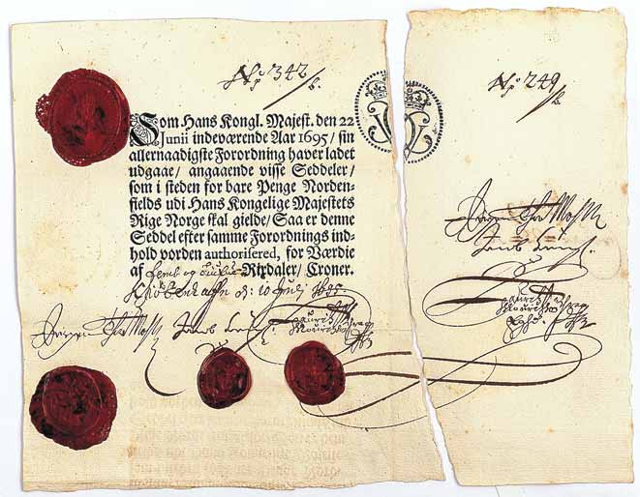
Illustration 1 Norway S3: Jørgen thor Møhlen 25 rixdaler kroner 1695
With counterfoil (from another note)
(image courtesy of Thomas Høiland Auktioner)

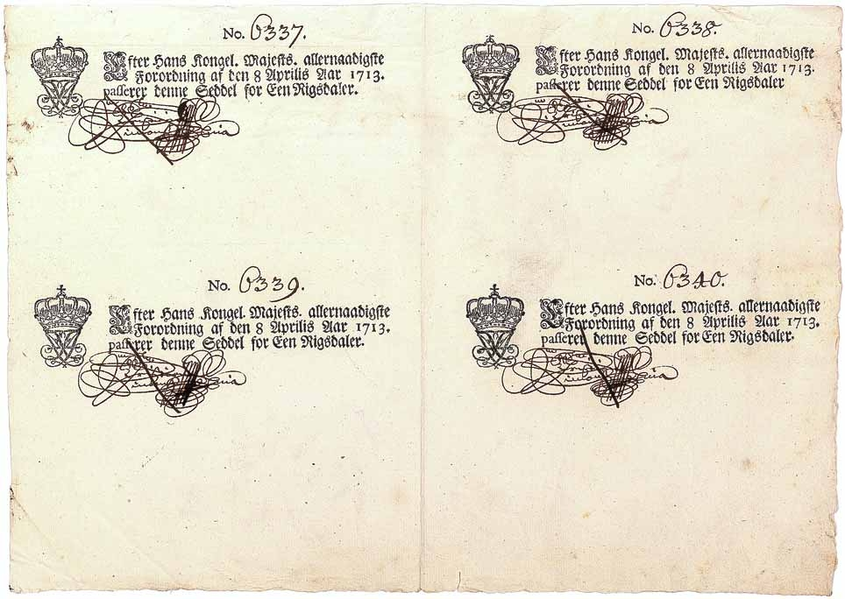
Illustration 2 Denmark-Norway S15 Authorised notes 1 riksdaler, unissued remainders
(image courtesy of Thomas Høiland Auktioner)

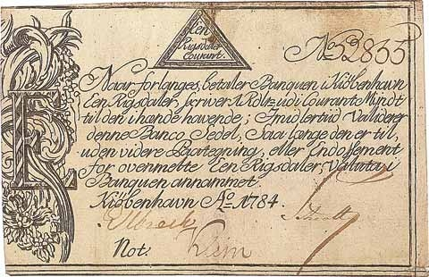
Illustration 3 Denmark-Norway S32c Kurantbanken series II 1 Riksdaler kurant
(image courtesy of Thoma Høiland Auktioner)
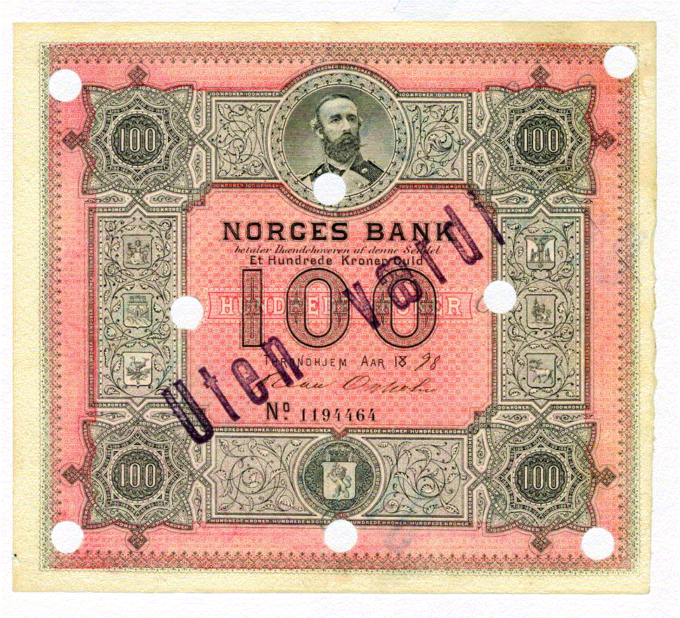
Illustration 4 Norge 1115 100 kroner series I 1898 stamped and hole cancelled.
(Image courtesy of Riibe mynthandel)

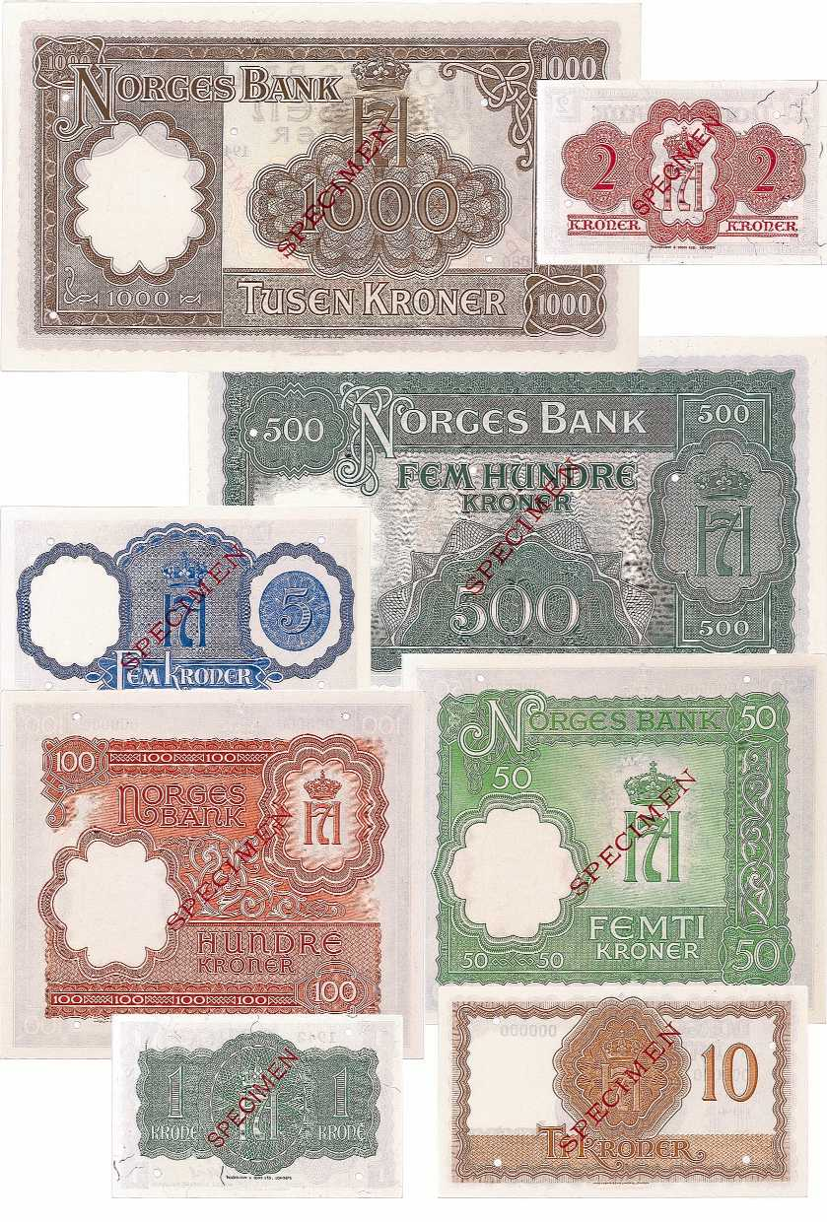
Illustration 5 Norway 1150-1157 London monetary reform issue, complete Specimen set (reverse).
(Image courtesy of Thoma Høiland Auktioner.)

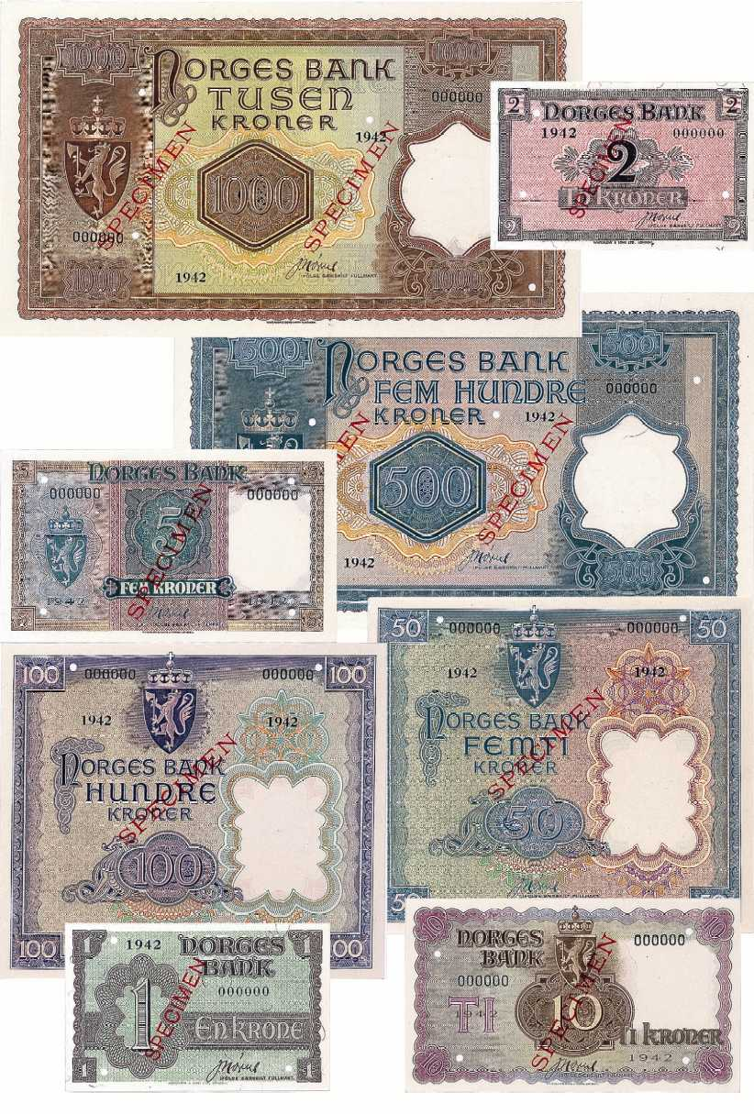
Illustration 6 Norway 1150-1157 London monetary reform issue, complete Specimen set (adverse).
(Image courtesy of Thoma Høiland Auktioner.)
References
Andersen, Gunnar. 1980: Pengesedler: Sikkerhedsgrafikkens principper og dens æstetik. 2nd edition. København: Danmarks Nationalbank.
Anderson, Benedict. 1991. Imagined communities. 2nd ed. London and New York: Verso. ISBN 0-86091-329-5
Erlandsen, Hans Christian. 1992: Penger av papir: Seddelens saga og sosiologi; seddelkunst og seddeltrykking; svindlere og samlere. Oslo: Grøndahl Dreyer. ISBN 82-504-1978-2
Fiske, John. 1990. Introduction to communication studies. 2nd ed. London and New York: Routledge. ISBN 0-415-04672-6.
Glahe, Fred R. 1973. Macroeconomics. Theory and Policy. New York-Chicago-San Francisco-Atlanta: Harcourt Brace Jovanovich. ISBN 0-15-551264-1.
Hewitt, Virginia H. and J.M. Keyworth. 1987. As Good as Gold: 300 Years of British Bank Note Design. London: British Museum Publications Ltd. ISBN 0-714108685.
Johansen, Øystein Kock. 2001. Fra stenpenger til Euro: Betalingsmidlenes forunderlige verden. Oslo: Den norske Bank. ISBN 82-996140-0-7.
Lindgren, Torgny. 1968. Riksbankens sedelhistoria 1668–1968. Stockholm: Rabén & Sjögren.
Lund, Niels Windfeld. 1999. Omrids af en dokumentationsvidenskab. Norsk tidsskrift for biblioteksforskning 12:24-46. ISSN 0804-6743.
Norges Bank. 2002. Årsrapport om betalingsformidling. Oslo: Norges Bank.
Platbārzdis, Aleksandrs. 1960. Sveriges första banksedlar: Stockholm Bancos sedelutgivning 1661–1668. Stockholm: Sveriges Riksbank.
Rønning, Bjørn R. 1980. Norges pengesedler og seddelbankvesen inntil 1874. Vol. 1, Sedler utstedt i København. Omfatter også Danmarks pengesedler 1713–1813. Oslo: Universitetsforlaget. ISBN 82-00-01929-2.
Scott, William A. 1930. Money and Banking. 6th ed. New York: Henry Holt and company.
Skaare, Kolbjørn. 1978. Mynt i Norge. Oslo: Det Norske Samlaget. ISBN 82-521-0837-7.
———. 1995. Norges Mynthistorie. Vol. 1, Mynter og utmyntning i 1000 år. Pengesedler i 300 år. Numismatikk i Norge. Oslo: Universitetsforlaget. ISBN 82-00-22666-2. Vol. 2, Katalog- og registerbind. ISBN 82-00-2667-0. Oslo: Universitetsforlaget.
Statistics Norway. n.d. “Arbeidslønn ved offentlige jernbane- og veianlegg. Daglønn. 1855-1915.” On the Internet: http://www.ssb.no/emner/historisk_statistikk/aarbok/tab-2000-09-20-03.html [Read 13.10.02] Copy with the author.
Stixrud, Kjell. 1995. Norske pengesedler 1817–1994: Seddelkunst. Nasjonal identitet. Oslo: Magistergradsavhandling i kunsthistorie, Universitetet i Oslo. [Master’s thesis in arts history, University of Oslo 1995].
Tonkin, Archie. 2002. Myntboken 2002. Ljungsbro: Tonkin AB. ISBN 91-7244-102-X.
van Wie, Paul D. 1999. Image, History and Politics: The Coinage of Modern Europe. Lanham, New York, Oxford: University Press of America. ISBN 0-7618-1229-9.

The first and second being the notes of the Stockholm banco 1661 and of the Bank of England 1694
Various spellings exist; Jørgen thor Møhlen is the more common and the one used by the Norwegian professional numismatists Rønning (1980, 20) and Skaare (1995, 1:232).
Except for the more recent notes, i.e. series IV and later, where I use actual notes as a basis for my analysis. A total of 150 different notes are included in the material, spread over 27 issues. As a help for my analysis the material from Rønning (1980) and Skaare (1995) has been tabulated in a spreadsheet. This spreadsheet is not included in an appendix,. The file will be accessible on the Internet, at the following address: http://www.janeriks.no/dv/Seddeloversikt.xls
2 notes issued by Rigsbanken 1813 are excluded; as no specimens exist the length of the text can only be guessed at.
Other interesting complexes could be scetches/essays/suggestions for note designs and trial notes, another papermaking with watermarking, fibers etc.
This paragraph is based on material from Rønning (1980) pp. 22–27. Royal decisions had a number of names (rescript, placat, cancelli-promemoria, forordning and so on); I generally use the term “royal decree” about such a piece of legislature.
The then Ministry of Finance
This paragraph is based on material from Rønning (1980) pp. 29–39.
The exact meaning of this term, literally “copper notes” is not given in the material I have accessed. It is possibly some kind of receipt that could circulate instead of the heavy copper coins.
This part is mainly based on material from Andersen (1980) and Erlandsen (1992).
Saussure uses the term semiology, not semiotics. I will use the term semiotics as the general term in this paper.
My translation
Actually at a press conference in the Northern lights planetarium at the University of Tromsø.
EFTPOS: Electronic Fund Transfer at Point of Sale, i.e. deducting money from an account by using a card at a terminal in order to pay for goods or services.
As a number of banks collapsed in the 1920’s and left the depositors only percentages of their deposits, one can well understand such suspicion. Today deposits are guaranteed by a fund.
One could, however, well imagine that the new design of banknote serial numbers lends itself well to electronic scanning and hence to a databased tracking of the “migration pattern” of individual notes.
Numbers beginning with an S are from Rønning 1980, numbers only are referring to Skaare (1995, vol. 2)

